Author name(s) (corresponding author), University of A, Country, email(s)

Author name(s), University of B, Country, email(s)

Author name(s), University of C, Country, email(s)

ZS style sheet and template

Publication guide in article form

**Abstract:** Research articles must have the main text prefaced by an abstract of no more than 200 words summarizing the main arguments and conclusions of the article. In order to be interpretable on its own, the abstract should not contain in-text citations or uncommon abbreviations prior to their introduction in the main text.

**Keywords:** about five keywords, separated by commas

# Introduction

The *Zeitschrift für Sprachwissenschaft* (ZS) welcomes manuscripts in English and German presenting current, original research results that have not been submitted or published elsewhere and do not overlap substantially with other publications. Authors are responsible for the grammatical and orthographic correctness of their submission, and non-native speakers of English should have their contribution carefully checked by a native speaker. Article manuscripts should not exceed 10,000 words. Reviews are either long (up to 1,500 words) or short (up to 500 words).

Submission of manuscripts involves uploading a PDF file on the journal’s website and, when the manuscript has been accepted for publication, providing the relevant source files (MS Word, Open/Libre Office, or LaTeX including auxiliary files). As all contributions undergo double-blind peer review, the PDF documents initially submitted must be anonymized, i.e. all information allowing conclusions about the authors, including metadata of the file, must be removed.

Articles are organized into numbered sections. Besides outlining the general topic and current research question and results, the introduction of an article (Section 1) provides basic information on the structure of the article itself, for instance by introducing its main sections: Section 2 of this style sheet supplies details on the design of text parts. Section 3 addresses citation and references. Section 4 covers orthographical conventions adopted by the ZS in the interest of consistency across contributions. Characteristics of reviews are presented in Section 5. The ZS kindly asks all contributors to install the Libertinus font family, details on which are provided in Section 6. Authors interested in the amenities supplied by this template to facilitate formatting chores are invited to find basic and more advanced directions for MS Word, including using paragraph styles adapted to the typographic design of ZS contributions, in Section 7. The style sheet concludes by exemplifying the order and layout of environments and sections that standardly conclude a contribution, namely acknowledgements, funding information, abbreviations, and appendix, if relevant, as well as references.

# Text-structure style[1]

The ZS styleis based on the proposal for “text-structure style” in *The Generic Style Rules for Linguistics*, to which we refer authors for rules that are not covered below (e.g. transliteration of non-Latin script). This section describes general and linguistic conventions on parts of an article. Section 2.1 is on sections, Section 2.2 on linguistic examples, followed by tables and figures in Section 2.3, the use of font for highlighting (Section 2.4), and abbreviations (Section 2.5). Footnotes illustrate footnote regulations where relevant (neither title nor abstract should feature a footnote).

## Sections

Each section and possibly subsection of the body of an article has a heading. While headings start with a capital letter, they do not internally feature special capitalization. Words following colons within headings usually begin with a small letter.

Sections and subsections are consecutively numbered, beginning with Section 1 (the introduction), followed by Section 2, Sections 2.1 and 2.2, etc. If a section is further organized into – at least two – subsections, a short introductory paragraph in between the section heading and the first subsection heading is possible and often recommended. More than three section levels (as in Sections 4.1.1 and 4.1.2) are rarely helpful. If a fourth level is necessary, unnumbered intermediary headings are possible, see Section 7.2.2. The following unnumbered sections may follow the body of the text in the following order: Acknowledgements, Funding, Abbreviations (see Section 2.5), Appendix (or Appendix A, Appendix B, etc.). The section References comes last.

If cross references to individual numbered or lettered sections, appendixes, tables, figures, or footnotes occur, these terms are not abbreviated. If the number or letter follows, the term is capitalized:

see Figure 7 and Footnote 4; see the analysis in the next section and data in the appendix

## Linguistic examples

Italics indicate exemplary linguistic material.[2] Linguistic annotation like square brackets around constituents are not in italic, but roman type. If linguistic material in the running text is from another language, a translation in single curly quotation marks follows immediately:

[…] everything is given and salient except for *reparieren* ‘repair’ […]

In numbered examples such as (1), the translation in single curly quotation marks follows in a separate line:

(1) *Du wirst es nicht glauben*  
‘You will not believe it’

If interlinear glossing is provided, each word in the example is aligned with its literal translation. In MS Word, words are aligned by use of one tab per word and a corresponding tab stop in an individually suitable position.[3] Where relevant, morphemic glossing follows the rules described in The Leipzig Glossing Rules.[4] For instance, the segmentable morphemes in (2) are separated by hyphens both in the example and gloss and abbreviations of glosses appear in small caps:[5]

(2) *Storm-ur-inn rak bát-inn á land.* (Icelandic)  
storm-nom-def drove boat-acc-def on land  
‘The storm drove the boat ashore.’  
[The Generic Style Rules for Linguistics, p. 7]

The source language can be given in round brackets after the example in italics, as in (2). Alternatively, the source language can be given a line preceding the example, as in (3):

(3) Icelandic  
*Storm-ur-inn rak bát-inn á land.*  
storm-nom-def drove boat-acc-def on land  
‘The storm drove the boat ashore.’

Bibliographical sources (see Section 3 on citations) can follow the example in italics and thus appear in the first line of the example environment in round brackets (possibly following the language), or they can appear in a line below the translation (depending on what parts of an example are taken from the source and on the space available). Other sources like corpora or texts are given in square brackets, see (2), usually in a short form and with more information given in the reference section or a separate section.[6]

Boldface can highlight expressions of interest within numbered examples, see (4a), small caps conventionally indicate (stressed) expressions in focus, see (4b).

(4) a. *The storm* ***drove*** *the boat ashore.*

b. *The storm drove the boat ashore.*

A preceding asterisk[7] indicates an ungrammatical example, and the intended meaning can be given in round brackets, see (5):

(5) \**The storm drived the boat ashore.*(‘The storm drove the boat ashore.’)

Each numbered example must be referred to in the running text. Adding “Example” before a bracketed example number in the running text is not necessary and not desired by the ZS.[8]

## Tables and figures

Like numbered examples, tables and figures are numbered consecutively and must be mentioned in the running text. Contributions in German use the (unabbreviated) expressions *Tabelle* ‘table’ and *Abbildung* ‘figure’ instead of their English equivalents. Paragraphs before tables and figures do not finish on a colon because tables and figures may shift to another position in their section in order to optimize the general layout of contributions. Table captions appear above tables, see Table 1, and figure captions appear below figures (e.g. Figure 1 in Section 7.1).

Table 1: Frequency of some English nouns (BNC)a

|  |  |  |  |  |
| --- | --- | --- | --- | --- |
| Singularb | | Plural | | % of singular |
| *person* | 24671 | *persons* | 4034 | 86 % |
| *house* | 49295 | *houses* | 9840 | 83 % |
| *hare* | 488 | *hares* | 136 | 78 % |

a Data and, partially, table layout are taken from The Generic Style Rules for Linguistics (p. 9).

b Headers usually begin with capital letters. Footnotes in tables appear below the table and use letters for reference, not numbers.

Tables and figures as well as captions (inserted via References > Captions > Insert Caption) employ the font Libertinus Sans instead of Libertinus Serif and standardly appear flush left or fit to the text (for tables: Table Tools > Layout > Cell Size > AutoFit Contents/Window). For details on the formatting of tables and the customized table style Table-ZS, see Section 7.2.2.

## Typographical means of emphasis: italics, boldface, and small caps

Special formatting should be used minimalistically to maximize its impact and reduce, rather than increase, readers’ processing costs. If used consistently according to their established functions, however, types of formatting greatly improve the readability of contributions.

Italics are used

* for linguistic examples in running text or numbered example environments;
* for book, journal, and film titles;
* for metalinguistic reference to technical terms (e.g. “calling these lexemes *discourse* rather than of *modal particles*”);
* for emphasis in general (“is *only* true if”);
* for emphasis in quotations if the change is indicated before the closing quotation marks: [emphasis mine]; and
* for introduction or intermittent emphasis of key terms, concepts, principles, etc.

Boldface can highlight expression of interest within linguistic examples, see (4a) in Section 2.2. Underlining should only be used exceptionally, e.g. to highlight a single letter in a word. All caps, quotation marks, or capitalization are not used for highlighting. Small caps are reserved for abbrevations of grammatical categories in glossing, see (2) and (3), and stress or focus in example sentences, see (4b).

## Abbreviations

Abbreviations can be helpful if they are common or reduce a *complex uncommon term* (CUT) that a text refers to frequently. In the latter case, the abbreviation is introduced in parentheses (sometimes together with a source, avoiding brackets following brackets) directly after the complex term is mentioned for the first time and in written-out form (see above). The abbreviation consistently replaces the complex expression in the following text, but not in the abstract, which must be interpretable in itself, and preferably not in section headings.

An alphabetical list of the abbreviations in a given contribution and their full forms can be provided in a designated section. Abbreviations of a certain category, e.g. glossing abbreviations, can be grouped together. If a set of glossing abbreviations is only relevant at one particular point in the contribution, providing the full expressions in a footnote is possible.

# Citation and references

The ZS adopts suggestions on citation and references from The Generic Style Rules for Linguistics while mostly retaining the reference style proposed in *The Unified Style Sheet for Linguistics*.[9] Slight adaptations of the previous proposals are simplifications to reduce “visual clutter” in the sense of The Unified Style Sheet for Linguistics and in the tradition of The Generic Style Rules for Linguistics. Section 3.1 is on citing and quoting, Section 3.2 is on references.

## Citation and quotations

Bibliographical sources of information appear as narrative or parenthetical citations in the running text, consisting of author surname(s), year, and page(s). If the surname features a prefix like *van* or *De*, the prefix is present in the citation and relevant for the alphabetic order of references, i.e. the prefix is not ignored or treated in a special way, and no difference is made between name prefixes beginning with capital letters and those beginning with small letters.Single pages or exact page ranges – the beginning and end page separated by an unspaced en dash – must be given after the year, a colon, and a space, unless the information concerns the entire source. In narrative citations, only the year and page (range) are in round brackets and usually appear directly after the author name, not separated from it (i.e. not, for instance, at the end of the clause):

[…] as van Gelderen (2022: 125–126) argues […]

In parenthetical citations, author names are in the round brackets as well, separated from the year by a space, but no comma. No extra brackets are used if the brackets contain information or expressions other than the source:

[…] not yet clear (for an overview, see Abraham 2024: 60).

The names of a pair of authors are conjoined by an ampersand. In case of more than two authors, the first author’s name is followed by the Latin expression *et al.* ‘and others’.[10] Several sources are usually ordered chronologically. Several contributions from the same author(s) and year are distinguished by small letters suffixed to the year:[11]

(Becker & Caspar 1999; Caspar et al. 2003; Abraham 2024a, 2024b; see Diderot 2011 for a syntactic analysis)

While sources are standardly identified by the authors’ surnames, certain surnames, e.g. of Chinese or Korean origin, are so frequent that giving the full name in the in-text citations may be helpful.

Citations following quotations in the running text appear after the closing curly double quotation marks and before a (final) punctuation mark:

“[…] everything in the clause is given” (Abraham 2024: 63).

Quotations in quotations are in curly single quotation marks and require citation of the source of the embedded quotation:

“[…] everything is ‘given and salient’ except for the verb” (Abraham 2024: 63; quoting Becker 2023: 18).

Any changes to the original, e.g. omissions, are indicated in square brackets. Quotations from other languages should be translated in square brackets directly after the quotation. Longer quotations can be translated in a footnote and should appear in a separate block, in which case quotations marks are omitted and the source is cited in brackets after the final punctuation mark:

The second factor is the learner’s need to be exposed to one or more languages (spoken or signed) to build the lexicon and to become familiar with interface constraints […]. Lexical differences are responsible for all cross-linguistic variation, and parameters are now only relevant to that domain […]. (van Gelderen 2022: 3)

Each citation, including citations in footnotes, citations in quotations, and citations of quotations in quotations, must correspond to an entry in the section References.

## References

Each source in the reference section must be referred to in the main text or a footnote of the contribution in the form of an in-text citation, see the preceding section. Unlike a bibliography, the reference section may not include entries on further reading if the sources in question are not also mentioned elsewhere. Information on primary sources of linguistic material (e.g. corpora or literary texts) can be provided in a separate section so that the reference section refers mostly to scholarly literature. Whether other types of sources, e.g. software packages, should appear among the references or in a separate section depends on the type and number of such sources. Please provide a DOI whenever available.

References are ordered alphabetically according to author name(s). Surname prefixes are regular parts of surnames, so that an entry for *De Schutter, Georges* would appear between *D’Alessandro, Roberta* and *Diesing, Molly*, an entry for *van Riemsdijk, Henk* would appear between *Umbach, Carla* and *Vermeulen, Reiko*. Several contributions by the same author(s) are ordered chronologically like in citations. Several contributions from the same author(s) and year are ordered alphabetically according to their titles, and small letters are suffixed to the year to ensure unique reference in citations, see Section 3.1 and Footnote 11.

The complete surname of the first author (or editor, in case an edited volume has been cited as a whole) is given first, followed by a comma and the given name in full, written-out form. Further given names are standardly reduced to initials, each preceded by a space. Authors that habitually publish under a different version of their name, e.g. only using initials or abbreviating their first, but not second given name, may exceptionally be referenced in their preferred style. All co-authors’ and all editors’ names that are not relevant for the alphabetic order of reference entries are given in the original order of given name and surname without a comma, i.e. the surname is only given first if this is originally its conventional position, e.g. in Chinese or Korean names. Two authors or editors are separated from each other by an ampersand. If more than two authors or editors are listed, an ampersand (no serial comma) appears before the last author’s or editor’s name, while commas separate all other authors or editors:

**Journal entry**

Blasi, Damián E., Joseph Henrich, Evangelia Adamou, David Kemmerer & Asifa Majid. 2022. Over-reliance on English hinders cognitive science. *Trends in Cognitive Sciences* 26(12). 1153–1170. <https://doi.org/10.1016/j.tics.2022.09.015>.

In a journal-article entry like Blasi et al.’s (2022), the article title is in roman font and begins with a capital letter, but has no special internal capitalization (*sentence case*). The journal title follows the article title in italics and features internal capitalization of lexical words (*title case*). Only a space separates journal title and volume number (in roman font, not italics). The issue number is optional and follows the volume number without a space and in round brackets. An en dash separates beginning and end page. Each part of the entry – names, year, article title, journal title and volume(/issue) number, pages – is separated from other parts by a period and space. Quotation marks are not used to highlight any parts of reference entries in general.

The entry for an article in an edited volume presents the article title just like the title of a journal article, after which all information on the edited volume is given (after the word *In* and a space, but no colon), independently of other entries that may feature the same information. Editors’ names are presented like authors’ names and followed by *(ed.),* (singular) or *(eds.),* (plural). Differently from article titles, book titles are in italics, but feature no internal capitalization. If any source has a subtitle, the subtitle is in sentence case, too, beginning with a capital letter after a colon and space. The beginning and end page of the article are given after the title of the edited volume and a comma and space.[12] After a period, one city and the publisher[13] are given, separated by a colon and space:

**Article in an edited volume**

Cristofaro, Sonia. 2017. Implicational universals and dependencies. In Nick Enfield (ed.), *Dependencies in language: On the causal ontology of linguistic systems*, 9–22. Berlin: Language Science Press. <http://dx.doi.org/10.5281/zenodo.573777>.

Edited volumes should receive an independent reference entry if and only if a citation in the contribution refers to the edited volume in general. The only difference to monograph entries is the addition of *(ed.)*/*(eds.)* after the name(s). If, optionally, a book series is mentioned (following the title in round brackets and roman font and featuring internal capitalization like a journal title), the number of the book within the series must be given as well:

**Edited volume**

Cangemi, Francesco, Meghan Clayards, Oliver Niebuhr, Barbara Schuppler & Margaret Zellers (eds.). 2018. *Rethinking reduction: Interdisciplinary perspectives on conditions, mechanisms, and domains for phonetic variation* (Phonology and Phonetics 25). Berlin: De Gruyter.

**Monograph**

van Gelderen, Elly. 2022. *Third factors in language variation and change*. Cambridge: Cambridge University Press. <https://doi.org/10.1017/S1360674323000114>.

The original publication year of reprints appears in square brackets after the year of reprint. Translations of titles in languages other than the language of the article may follow the original title in square brackets and in roman:

**Reprint**

Weinhold, Karl. 1967 [1883]. *Mittelhochdeutsche Grammatik* [Middle High German grammar]. Paderborn: Schöningh.

Information on a volume number or edition may follow a book title after a comma or period, respectively:

**Monograph with volume and edition information**

Eisenberg, Peter. 2013. *Grundriss der deutschen Grammatik: Das Wort* [Outline of the German grammar: The word], vol. 1. 4th edn. Stuttgart: Metzler. <http://dx.doi.org/10.1007/978-3-476-00757-5>.

Theses are presented like monographs with a university[14] as the publisher. The type of thesis follows the university without a comma before the final period:

**Thesis**

Sahlgren, Magnus. 2006. The word-space model: Using distributional analysis to represent syntagmatic and paradigmatic relations between words in high-dimensional vector spaces. Stockholm: Stockholms universitet dissertation.

Reference entries may feature additional information, which generally appears at the end of entries after a period, for instance a DOI (without an access date):

**Monograph available online**

Winter, Bodo. 2019. *Statistics for linguists: An introduction using R*. New York: Routledge. <https://doi.org/10.4324/9781315165547>.

Sources that are neither articles nor books are presented like articles or books as far as possible, with further information following. Online sources other than articles or books are presented similarly to books as well. An organization or group may replace the authors, and a city and publishing organization (in case a group provides the source) can be specified if available. The year can be the publication year, the year of the last change, or a range of years where relevant. Note that URLs generally require an access date:

**Online sources**

Native Languages of the Americas. 1998–2020. *Vocabulary in Native American languages: Salish words*. <http://www.native-languages.org/salish_words.htm>, 28 February 2025.

R Core Team. 2021. *R: A language and environment for statistical computing*. Vienna: R Foundation for Statistical Computing. <https://www.R-project.org/>, 28 February 2025.

Proceedings contributions are presented like journal articles. The name of the society, omitting additions like “Proceedings of / Papers from the Annual Meeting of the”, serves as the journal title and is immediately followed by the acronym in brackets (in roman), itself followed by the volume/conference number:

**Proceedings contribution, journal-article style**

Crain, Stephen & McKee, Cecile. 1986. Acquisition of structural restrictions on anaphora. *North East Linguistics Society* (NELS) 16. 94–110.

For, for instance, papers presented at meetings or conferences, the type of contribution and information on the event are provided as non-standard information following the title. Conference or meeting names are generally in title case:

**Paper presented at a conference**

Faller, Martina. 2019. Alternative-sensitive enclitics and focus in Cuzco Quechua. Paper presented at the Stress-Free Focus Workshop, Universität Wien, 18–19 October.

# Orthographical conventions

For consistent British or American spelling, the ZS refers to the Oxford English dictionary (-*ize* endings) or Merriam-Webster, respectively. Grammar and punctuation rules (e.g. Oxford serial comma or not) should be consistent. On the presentation of units of measurement, see the latest SI brochure.[15] Frequently occurring matters of orthography and the conventions explicitly adopted here are listed in the following; on capitalization, see Section 4.2, on punctuation, see Section 4.1.

## Punctuation

In the interest of consistency across contributions, the ZS adopts the following conventions for hyphens and dashes as well as quotation marks.

### Hyphens and dashes

In hyphenating compound modifiers (*spatialization-of-form hypothesis*), we recommend following Oxford conventions. The ZS also employs the hyphen, rather than the en dash, instead of a solidus (*/*) in expressions like *editor-author relationship*.

En dashes introduce entries in vertical lists, see e.g. Section 2.4. Unspaced en dashes indicate ranges: *pp. 23–31*, *see (7a–c)*.[16] The ZS uses spaced en dashes as parenthetical dashes:

The ZS employs spaced en dashes – rather than unspaced em dashes, which are twice as long and uncommon in some languages – as parenthetical dashes.

### Quotation marks

Please use curly quotation marks and apostrophes. Quotations are in double quotation marks, quotations in quotations are in single quotation marks. If an incomplete sentence is quoted, punctuation may follow the final quotation marks:

Illustrating that “all conventionally implicated content is assigned ‘the same semantic force as a main clause’”, the paper supports Potts’ (2005) insight […]

Single quotation marks are also used for translations of exemplary linguistic material, see Section 2.2. Instead of single quotation marks, italics are used to introduce or highlight expressions from the literature that are not presented as quotes in double quotation marks.

## Capitalization

Internal capitalization of lexical words, i.e. title case, applies to expressions that can be regarded (or belong to) proper names. Conferences, journal titles, and book series can be regarded proper names in the widest sense. When a part of a text is referred to individually by providing the type of text part and number, the expression is used like a proper name and without a definite article and features an initial capital letter too (*in Section 2.2*, *Footnote 1*, *Table 3*, *Figure 4*, *Year 5*, *Semester 6*, *Experiment 7*; likewise *see Appendixes A to C*; etc.).[17]

The use of title case is on the decline in linguistics and in general. Book and article titles, like section headings and table and figure captions, are regarded to provide information and only feature an initial capital letter, i.e. sentence case, according to many contemporary styles. Subtitles of books and articles also feature initial capitalization, which follows a colon in reference entries. Since neither section headings nor captions feature subheadings or “subcaptions” comparably to titles or headlines, information following a colon within a heading or caption usually begins with a small letter.

Capitalization should be used only if absolutely necessary. In particular, title case should not be used for hypotheses, principles, theories, etc.: *the minimalist program*, *word-space model*, *the spatialization-of-form hypothesis*.[18] Capitalization is not required to establish the intended reference of such expressions in a given context in written or oral language but often presents unnecessary processing costs and decreases readability, not least due to its overall inconsistent application. Title or sentence case are not used for highlighting; introduction, metalinguistic reference, or emphasis in general is indicated by use of italics.

# A note on reviews

Contributions titled *Book review* feature details on the reviewed volume in their subtitle, in four parts separated by periods in the following form:

**Name**(**s**). *Title: Subtitle*. City: Publisher year (Book Series [number]). Pages.

1. Names are presented in boldface in their native order of given and family names, with two or more authors or editors (*(eds.)*)separated by commas.
2. Titles and subtitles feature title case.
3. Next are a city, colon, publisher and, immediately, year, possibly followed by a book series and number in round brackets.
4. Pages feature at last, i.e. possibly *Roman + Arabic* numbers followed by *pages*.

To illustrate:

**Marianna Bolognesi**, **Ana Werkmann Horvat**. *Metaphor Compass: A Guide to Language, Cognition, Communication, and Creative Metaphor Research*. New York: Routledge 2023. xiv + 189 pages.

**Friedrich Markewitz**. *Ironie*. Heidelberg: Universitätsverlag Winter 2024 (Kurze Einführungen in die germanistische Linguistik 31). 99 Seiten.

**Claus Altmayer**, **Katrin Biebighäuser**, **Stefanie Haberzettl**, **Antje Heine** (Hgs.). *Handbuch Deutsch als Fremd- und Zweitsprache: Kontexte – Themen – Methoden*. Berlin: J.B. Metzler 2021. 429 Seiten.

Volume titles mentioned within the body of contributions also display title case. Instead of the ampersand, *and* conjoins the last of two or more names if the review mentions the authors or editors of the reviewed volume.

# Font: Libertinus

ZS contributions use the non-proprietary typeface Libertinus, most prominently Libertinus Serif for running text and Libertinus Sans for some special environments like titles, headings, and tables. We kindly ask authors to install the Libertinus font family, which is available for free on GitHub.[19] Adding this font in Windows involves

* downloading the zip folder,
* extracting its contents, and
* either installing the OTF files (in the OTF folder inside the “static” folder) by selecting the menu option Install, available after right-clicking on (a group of selected) folders,
* or dragging and dropping the OTF files into the C:\Windows\Fonts folder for windows to install them automatically.

# Formatting of contributions

This style sheet is overall formatted like a ZS article and provides prototypes of the environments found in linguistics contributions. Typographically, environments like headings, quotations, linguistic (sub)examples, or reference entries are paragraphs distinguished by various characteristics. Section 7.1 contains a few remarks on word processing at a basic level that may help contributors in working with this article template. Section 7.2 is on predefined formatting styles that can save authors much time. Section 7.3 provides guidance on how to handle the example numbers (which are instantiations of field functions rather than plain text), bookmarks, and cross references in this template. Please feel free to contact the ZS editorial team about formatting issues.

## Basic word-processing techniques

The most basic approach to using this template is to replace its text with new text in environments relevant to a new contribution and to delete non-relevant environments. An essential operation in such an approach is to copy and paste environments in order to multiply, for instance, (parts of) linguistic examples before replacing text. A few convenient keyboard shortcuts not peculiar to MS Word are likely known to any user:[20]

* Undo: Ctrl+Z
* Redo: Ctrl+Y
* Copy (of selected text): Ctrl+C
* Cut (and copy selected text): Ctrl+X
* Paste: Ctrl+V
* Search for: Ctrl+F
* Save changes: Ctrl+S

Text or entire paragraphs including their formatting features can be copied and pasted or the formatting of paragraphs or text can be copied and pasted. Whether paragraph formatting is retained after pasting depends on whether paragraphs were copied partially or entirely. To demystify effects and manage any document efficiently, activate the *pilcrow* a.k.a. paragraph symbol (¶) in Home > Paragraph, see Figure 1. Environments like linguistic examples usually retain their formatting when final paragraph marks are selected as well, see Figure 2.

To (re)define formatting, copy and paste formatting of text (font features; after selecting a portion of a paragraph) or formatting of paragraphs (after selecting an entire paragraph including the pilcrow or placing the cursor into a paragraph):

* Copy formatting: Ctrl+Shift+C
* Paste formatting: Ctrl+Shift+V

Formatting can be copied and pasted across documents. For more information, hover over Home > Clipboard > Format Painter. In order to identify indentations and tab stops – key features of many non-standard paragraphs – the document settings should show the ruler above the document, which can be activated in View > Show > Ruler.

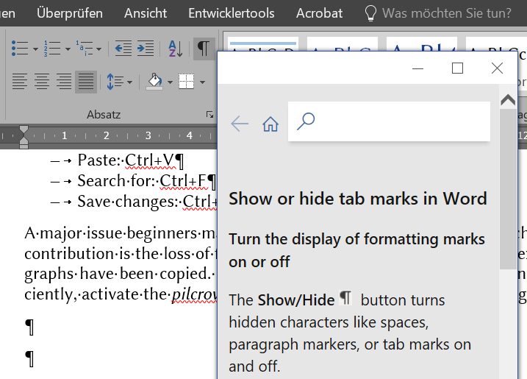

Figure 1: Activated pilcrow button to show formatting marks (e.g. tab marks between en dashes and list items, dots in spaces between words, hard returns at the end of paragraphs)

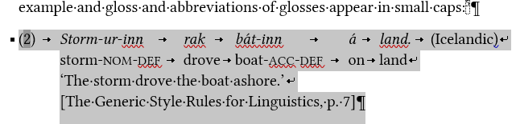

Figure 2: Selection of a paragraph comprising a (basic) linguistic example: final pilcrow selected

The Reveal Formatting task pane can be used to compare the formatting of paragraphs in the same document in order to make adjustments:

* Reveal Formatting: Shift+F1

Seeing different parts of a document on the same screen and being able to work in either of them can alleviate many tasks:

* Split the document window: Ctrl+Alt+S

MS Word reveals many helpful keyboard shortcuts when hovering the mouse over word icons. Besides keyboard shortcuts, ribbon shortcuts are especially helpful with frequent commands that are cumbersome to execute via the ribbon using a mouse or touchpad. While keyboard shortcuts require pressing several keys at once (+), ribbon shortcuts require pressing several keys successively (>). The letter keys assigned to menu ribbon tabs and icons depend on language settings, but all ribbon shortcuts start with Alt to show the Key Tips on the ribbon menu. Next, press the letter key assigned to the relevant menu tab, thus revealing the Key Tips for options in that menu tab. To illustrate, in German language settings and with a corresponding keyboard, the first of the following ribbon shortcuts (de)activates tab marks via Home (“R”) > Show/hide tab marks (“8”). The second ribbon shortcut opens the Cross-reference dialog box via Insert (“I”) or References (“V”; German *Verweise*) > Cross-reference (“Q”; German *Querverweis*):

* Show/hide tab marks: Alt > R > 8
* Open Cross-reference dialog box: Alt > I (or V) > Q

Finally, navigating a menu (enter via Alt or F10) or document (moving the cursor, selecting text) by means of the keyboard (arrow keys, Pos1, End) can save much time. To illustrate:

* Move cursor one character/line: Arrow key (left/right/up/down)
* Move cursor one word/paragraph: Ctrl+Arrow
* Select one character/line: Shift+Arrow
* Select one word/paragraph: Ctrl+Shift+Arrow

These keyboard commands are exemplary and intended to invite interested users to familiarize themselves with the general approach. They can be combined. For instance, keeping Ctrl+Shift pressed and pressing Left three times selects the last three words. After letting go of Ctrl, Shift+Left arrow will add the space to the left to the text thus selected. Such operations can be a hassle with a mouse or touchpad.

## Predefined formatting styles

This section is on paragraphs in the sense of typography. Such textual environments include the standard paragraph in running text but also the title, subtitle, abstract, headings, long quotations, footnotes, linguistic examples, entries in vertical lists, reference entries, figure/table captions, etc. This template provides examples as well as predefined formatting styles for most such environments. Authors can quickly define the intended type of paragraph – i.e., conjure up in moments all the associated settings in terms of indents, font features, hyphenation, etc. – by selecting text or a paragraph and choosing for it one of the predefined formatting styles in Home > “Styles gallery” or in the Styles pane:

* Open Styles pane: Ctrl+Alt+Shift+S

If relevant styles seem to be missing, other settings in Options may show more styles. Instead of copying text into this template, authors preferring to adjust a pre-existing manuscript can, in their source file, open the Manage Styles dialog box and use the Import button at its bottom to open the Organizer and be able to import styles from this template into their own document. Section 7.2.1 introduces the features of standard paragraphs and the Standard style, which subsumes these features. Section 7.2.2 presents more information on (how to use which) non-standard styles, especially those designed for linguistic examples and (types of) subexamples in the text and footnotes.

### Standard paragraphs

The Standard style is the basis for defining most non-standard paragraph styles, which are generally defined by specifying differences to the Standard style. Hence, changes to the Standard style usually affect other paragraph styles. The following features of standard paragraphs in running text are predefined in the Standard style:

* Standard paragraphs are fully justified, i.e. flush left and right.
* The standard font is Libertinus Serif, size 11 pt.
* Paragraphs feature a spacing of 8 pt after (either Layout > Paragraph or Home > Paragraph > Paragraph dialog box) and a line spacing of 1.15 (Home > Paragraph).
* Paragraph settings (Line and Page Breaks) standardly include “Widow/Orphan control”.
* Standard paragraphs employ automatic hyphenation (Layout > Page Setup).
* The language default of this template is English (UK).

Language settings need to be correct because they impact hyphenation, which is standardly activated for fully justified paragraphs. If a contribution is overall written in another language, the Standard style should be adapted in Home > Styles by right-clicking on Standard (after opening the Styles pane, if necessary) and selecting Change > Format > Language. Where another language features intermittently in a contribution, the proofing language can be adjusted manually (either at the bottom of the window or in View > Language > Set Proofing Language).

Note that the standard paragraph is the only intermediary level of information packaging in between the sentence and containing (sub)section. Readability does not benefit from further differentiations between more or less independent or prominent types of paragraphs. In particular, paragraphs in scholarly literature usually consist of several sentences separated from each other by single empty spaces, and each paragraph is separated from an adjacent paragraph by means of one hard return. No soft returns are permitted inside paragraphs in running text. Empty lines are generally not recommendable: If an argumentative turn does not warrant the division of a section into subsections, it can usually be introduced in a regular new paragraph, given that (sub)section-initial introductory paragraphs conventionally anticipate important argumentative turns.

### Non-standard paragraphs and associated styles

This template provides several non-standard paragraph styles adapted to or created in the ZS design, such as:

* Author
* “Article title” and “Article subtitle”
* Abstract, for abstract and keywords
* “Zitat,Quotation”, for long quotations in indented blocks
* “Überschrift 1,Heading1”, likewise 2, 3, and 4; the latter “unnumbered”
* “Acknowledgements”, for acknowledgements as well as funding information, as illustrated below
* “Listenabsatz,List paragraph”, for entries in vertical lists introduced by en dashes
* “Reference entry”

Additionally, after creating a table via Insert > Table and selecting the result, Table Tools will show in the ribbon and make a table style Table-ZS available under Design > Table Styles; see the final part of this section for details.

Some styles are usually of minor concern to authors since they appear in the process of taking certain actions. For instance, the features intended for captions of tables and figures are defined in the paragraph style “Beschriftung,Caption”, which appears upon selecting a table or figure and selecting Insert Caption (either by opening the menu via a right click or the menu key and selecting Insert Caption or by navigating to References > Captions > Insert Caption).

Similarly, inserting footnotes via the menu or Ctrl+Alt+F will produce, first, footnote references in the style of “Fußnotenzeichen,Footnote reference”, which superscripts the reference numbers in the text and footnote itself and is a text style rather than paragraph style. Second, the cursor moves to the beginning of the paragraph styled as “Fußnotentext,Footnote text” that is newly established at the bottom of the page. While authors thus do not need to select those styles directly in order to create the paragraphs in question, authors wanting to adjust footnotes or captions in general, e.g. regarding language settings, may save time by adapting the predefined styles rather than individual footnotes or captions.

Styles differ not only regarding the features characterizing the relevant paragraphs but also regarding the type of paragraphs created by a hard return. For instance, pressing Return after typing in a heading creates a paragraph in Standard style, pressing Return at the end of a reference entry formatted as such creates another paragraph in “Reference entry” style. Against this backdrop, four styles serve to create formatting environments for basic examples and (first, medial, and final) subexamples, as introduced below. The subsequent part of this section is on general footnote features and the two styles designed for basic examples and subexamples in footnotes.[21] The section concludes by discussing the ZS table design.

#### Basic linguistic examples

Selecting the style “Linguistic example basic” creates the following environment for basic linguistic examples, which may feature glosses and translations but do not feature subexamples, as in (1) to (3) as well as (5) in Section 2.2, see Figure 3:

* hanging indent at 1 cm  
  (ensures correct alignment of original, glosses, and translation)
* flush left  
  (prevents lines from stretching to the right margin when using soft returns)
* Line and Page Breaks > “Keep lines together”  
  (keeps the example on one page, can be unchecked for examples of unusual length)

This environment requires a tab, not spaces, after the example number in round brackets,[22] as well as soft returns to start new lines for glosses and translations within the example. A hard return after the final line, e.g. the source in square brackets in (2), creates a standard paragraph.

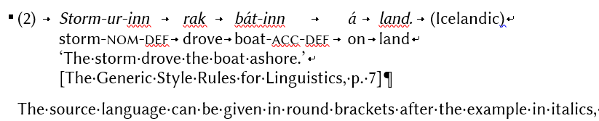

Figure 3: Basic example, formatting symbols showing

Besides tabs after the number in round brackets and between glossed words, soft returns after non-final example lines, and a hard return ending the typographical paragraph after the final line, Figure 3 shows the formatting symbol for “Keep lines together”, a black square to the left of the first line of the paragraph (▪).

#### Linguistic examples featuring subparts

For convenience, the style for each subpart of an example (Subexample a, b, c, etc.) is separately defined, due to small yet essential differences in formatting. “Linguistic subexample a.”, as opposed to “Linguistic example basic” is characterized as follows:

* spacing of 6 pt after
* tab stop at 1 cm  
  (where *a.* appears, with which glosses, translations, etc., should not align)
* hanging indent at 1.5 cm

Since examples that only feature two subexamples are presumably more frequent than examples that feature three or more subexamples, a hard return after the last line of a “Linguistic subexample a.” creates a “Linguistic subexample final”:

* spacing of 6 pt before but 8 pt after
* left indent at 1 cm, hanging indent at 0.5 cm (relative to the position of left indent; further lines in the paragraph beginning at 1.5 cm from left margin)

For examples with more than two subparts, select “Linguistic subexample medial” for each subexample that is neither initial nor final, creating a paragraph spacing of 6 pt before and after. The settings for left and hanging indents in medial subexamples are the same as for final ones, ensuring that the first line begins at the position for *b.* or *c.* etc. while, after soft returns, following associated lines begin aligned with the linguistic example in the narrow sense. Hard returns after “Linguistic subexample medial” create paragraphs styled as “Linguistic subexample final” again (as examples featuring three subparts are presumably more frequent than examples featuring even more subparts).

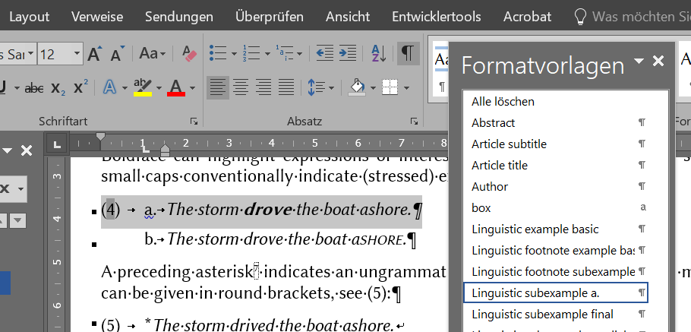

Figure 4: “Linguistic subexample a.”

To illustrate, Figure 4 shows (4a) from Section 2.2. The entire paragraph is selected, and the Styles task pane (*Formatvorlagen*; shortcut to display Ctrl+Alt+Shift+S)identifies its formatting as “Linguistic subexample a.”. A tab-stop and hanging-indent symbol are sitting on the ruler (View > Show > Ruler) above the text at 1 cm and 1.5 cm, respectively. In comparison, Figure 5 shows the left and hanging indents of (4b), a paragraph styled as “Linguistic subexample final”.

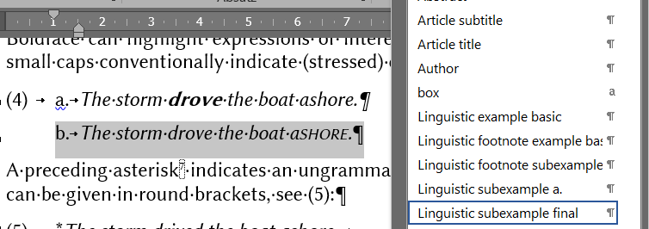

Figure : “Linguistic subexample final”

To add another subexample to an existing example, simply start a new paragraph by means of a hard return and, if necessary, select the style yielding the intended format. The style of an adjacent paragraph may need to change as well. For instance, (6) was created as follows:

* copying and pasting (4)
* (selecting the example number – a members of a numbered list, see below – and updating it by pressing F9)
* (selecting the number and defining a bookmark – Example_abc – for it via Insert > Bookmark or via the ribbon shortcut Alt > I > K in order to allow for the automatic cross reference above this list, itself created via Alt > I > Q)
* placing the cursor behindSubexample b andpressing Enter, thus creating a new standard paragraph
* selecting “Linguistic subexample final” as the style for the new paragraph
* adding text (*c.* in roman followed by a tab and the example text in italics)
* placing the cursor before Subexample b and selecting the style “Linguistic subexample medial” to reduce the spacing in between Subexamples b and c to the intended 6 pt
* changing the formatting of the text in (6b) back from roman to italics[23]

(6) a. *The storm* ***drove*** *the boat ashore.*

b. *The storm drove the boat ashore.*

c. *New final subexample*

#### Footnotes: text and linguistic examples

To ensure consecutive numbering and allow for automatic cross references, footnotes must be inserted by selecting References > Insert Footnote or by means of the shortcut Ctrl+Alt+F. Standardly, footnote references appear superscript yet otherwise formatted like the surrounding text. The following features characterize footnote text:

* font size 9, line spacing of 1.04
* like standard paragraphs: fully justified, automatic hyphenation
* unlike standard paragraphs: no spacing

This template provides two styles for linguistic examples in footnotes. The style “Linguistic footnote example basic” creates a paragraph with the following characteristics:

* flush left, ensuring that soft returns can be used to create new lines for glosses and translations without stretching the lines inside (sub)examples
* hanging indent at 0.75 cm, ensuring that glosses/translations align with the beginning of the original example
* Line and Page Breaks > “Keep lines together”

“Linguistic footnote subexample”, intended for examples (ia), (ib), etc, differs regarding the following features:

* tab stop at 0.75 cm, the position at which *a.*, *b.*, etc., appear preceding the position at which the original example begins, with which glosses, translations, etc., need to align
* hanging indent at 1.25 cm, where the original example and subsequent associated lines begin

For illustration and further information, see Footnote 24.[24]

#### The ZS table design

After creating a table via Insert > Table and selecting the result, Table Tools will show in the ribbon and make a table style Table-ZS available under Design > Table Styles. Table-ZS subsumes the following features:

* Font: Libertinus Sans, 11 pt
* Paragraph spacing of 3 pt before and after, single-spaced lines
* Header row in boldface
* No vertical lines, border lines of 0.5 pt on top and bottom and below the header row

For some reason, some special settings of a table format will appear upon selecting this table format if and only if the Standard style in a document complies with default settings. In other words, in this document, Libertinus Serif (11 pt) has been “Set as Default” in Home > Font, and Word therefore adopts it as the font of Table Normal style, which Table-ZS is based on. As a consequence, Word is willing to change the font of a table in Table-ZS style to Libertinus Sans. Likewise, the line spacing of 1.15 pt and paragraph spacing of 8 pt after have been “Set to Default” in Home > Paragraph, so the Standard style and Table Normal style converge and Word allows for the change to single-spaced lines and a paragraph spacing of 3 pt before and after in a Table-ZS environment. Therefore, please check whether your table settings comply with the features listed above even after selecting the style Table-ZS.

Tables may appear flush left and fit to contents or fit to the surrounding text (see Table Tools > Layout > Cell Size). Please insert captions after selecting the table via References > Captions > Insert Captions. Naturally, whether cell content appears centred, flush left/right, or fully justified and whether hyphenation should be deactivated (Home > Paragraph > Line and Page Breaks) depends on the content. Sentence case standardly applies to header-row cells but not necessarily to the first column or other cells. The final positions of tables and figures within their sections may change in order to optimize the use of space and general page layout. Therefore, the running text must contain references to each table and figure and paragraphs before tables and figures do not finish with a colon.

## Consecutive numbering, bookmarks, and cross references

This section is on the example numbers (Section 7.3.1), bookmarks, and cross references in this template, which are instantiations of underlying variables, or *field functions*. Altogether, using field functions instead of plain text ensures, first, the consecutive numbering of examples even if their order changes, new examples are inserted in between existing ones, or examples are deleted intermittently. Second, bookmarks and cross references can adapt to the new values of examples in the wake of such changes. Third, proper cross references can be retained even in converting documents into PDF format, so the electronic versions of a contribution are navigable for readers, i.e. readers can jump to a cross-referenced text part by clicking on the cross reference.

Users preferring plain text can, of course, delete and replace any of the fields involved. Alternatively, after selecting text that includes fields (e.g. globally: Ctrl+A), the latter will turn into plain text upon executing the following command:

* Convert fields into plain text: Ctrl+Shift+F9

Otherwise, copying and pasting example/figure/table/heading/footnote numbers and cross references in this template will not merely yield a copy of the visible text. Instead, copies of fields will retain all the properties of the original fields.[25] While some such numbers (section headings) will automatically update at every change to their sequence, other copied numbers may look exactly like their originals at first, but an update of selected fields will adjust their values relative to the other numbers of the same type and depending on their current position in the document. When many example/table/figure numbers and associated cross references, e.g. all the ones following the point of an intermittent change, require refreshment at once, all content can be selected (of either running text or footnotes – notice that both require separate updates):

* Select all content (in either running text or footnotes): Ctrl+A
* Update selected fields: F9

Fields, including cross references, will usually adopt correct values after refreshment. Should the document at some point contain cross references referring to items that were meanwhile deleted, an error message will come up: *Error! Bookmark not defined.*[26] The exact message depends on language settings; searching for exclamation marks will identify or rule out cross references in need of repair (measures: show tab marks, delete field with error message entirely, cross-reference correctly).

When copying and pasting fields, carefully distinguish between the numbers of e.g. linguistic examples and cross references to them. Copying and pasting an example number is possible in order to create another example number but not to create a cross reference to the original example. If the latter happens, an update will let the would-be cross reference take on the cardinal value in between the previous and subsequent linguistic example. In case of doubt about the specifics of a field, the following commands toggle between field functions and their results:

* Show/Hide field codes globally: Alt+F9
* Show/Hide code of selected field: Shift+F9

### Numbering linguistic examples

To ensure consecutive numbering and eventually allow for navigable cross references of numbers only (i.e. excluding round brackets from Word fields to allow for the inclusion of *a*, *b*, etc. in the brackets), example numbers should not be created in Home > Paragraph. Instead, brackets are added manually, and the following steps create the example number as a member of a number sequence:

* Insert > Text > Quick Parts > Field (see Figure 6)

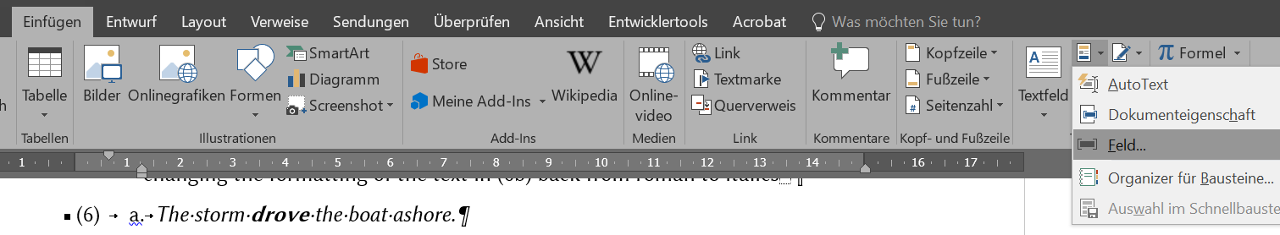

Figure 6: Finding Field in Quick Parts

* In the Field window, select Seq and add an *individual* name for your number sequence after “SEQ” in “Field codes”, see Figure 7. (The option “Preserve formatting during updates” should be selected.)
* After clicking OK, the example number will appear.

Repeating the above steps using the same sequence name[27] will yield the next number in the sequence, relative to previous numbers in the document. If an example number is added in this way in between existing examples, the numbers of the following examples (and corresponding cross references) need an update, e.g. via selecting everything by means of Ctrl+A and pressing F9.

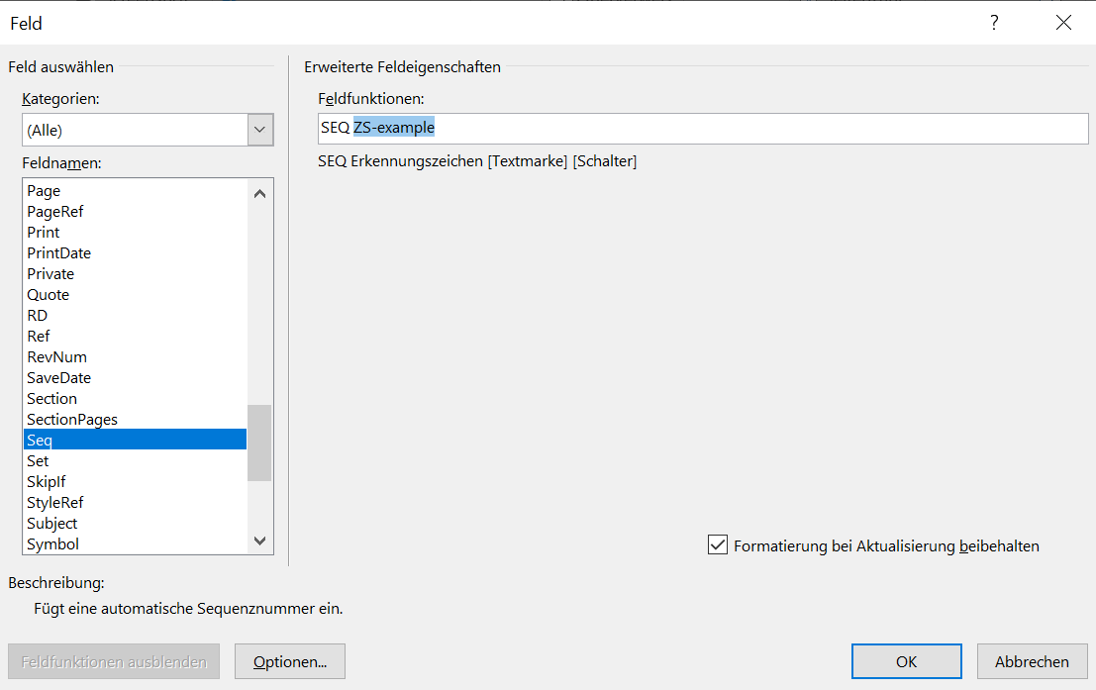

Figure 7: Creating a sequential number

Numbers from a sequence or entire examples using sequential numbers can be copied and pasted. While, at first, the result looks identical on the surface, each of the numbers will take on an individual value according to its position in the document relative to other numbers of the same sequence after updating (again, Ctrl+A > F9).

### Bookmarking example numbers

Cross-referencing sequential numbers in Word is possible after bookmarking. To attach a bookmark to an example number (actually, to the field underlying the number), select only the number without the brackets, open the Bookmark dialog box via Insert > Links > Bookmark, and name the bookmark (empty spaces and some symbols are disallowed), see Figure 8.

Note that bookmarks can be displaced along with the field or text they are attached to by being *cut* and pasted (Ctrl+X, Ctrl+V). However, they cannot be *copied* and pasted, i.e. each bookmark remains attached to the field or text it was originally placed on, because bookmarks are meant to provide *unique* referents for cross references. The copy of a linguistic example featuring both a sequential number (see the previous section) and bookmark will thus only feature a sequential number (different from the original sequential number after a field update) but no bookmark.

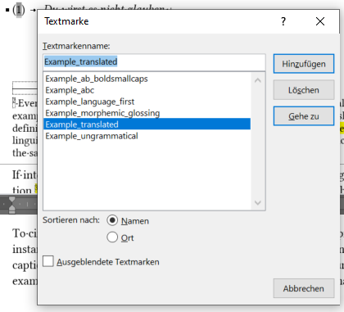

Figure 8: Bookmark (German *Textmarke*) dialog box showing *Example_translated* as the bookmark on *1*

### Cross references

Any type of cross reference – to section numbers, bookmarked example numbers, footnote numbers, tables, figures – enters the document via either Insert > Links > Cross-reference or References > Captions > Cross-reference. Both paths open the Cross-reference dialog box. For cross-referencing a section number, select “Numbered item” or Heading as “Reference type”, then select “Heading number” in the “Insert reference to” box. Make sure that “Insert as hyperlink” is enabled, select the intended heading in the “For which” box, and confirm by clicking Insert or pressing Return.

To cross-reference bookmarked linguistic example numbers, open the Cross-reference dialog box and select Bookmark, “Bookmark text”, and the name of the bookmark/example. In case of doubt about the right name, select a bookmarked number in the text and open the Bookmark dialog box (Insert > Links > Bookmark). The highlighted name is the name of the bookmark selected, see Figure 8 above. Should the selected number not feature a bookmark, the last bookmark name in the Bookmark dialog box is highlighted by default.

Footnotes are an extra item in the “Reference type” box but cross-reference in the same way as heading numbers or bookmarks on linguistic example numbers. In all those instances, only a hyperlinked number appears while words like *Section* or *Footnote* or round or square brackets and lowercase letters indicating subexamples are not part of the field.

In contrast, cross-referencing figures and tables in the conventional way allow only the selection of “Only label and number”, i.e. the word *Figure* or *Table* is part of the field and cannot be modified permanently. To circumvent the ensuing grammatical limitations and be able to cross-reference only the numbers in, for instance, *Figures 1 and 2*, bookmarks can be assigned to only the numbers in figure and table captions, in the same way as a bookmark is assigned to each of the numbers identifying linguistic examples. (This template only features bookmarks on example numbers.)

Acknowledgements: […]

Funding: […]

# Abbreviations

[…]

# Appendix

[…]

# References

Blasi, Damián E., Joseph Henrich, Evangelia Adamou, David Kemmerer & Asifa Majid. 2022. Over-reliance on English hinders cognitive science. *Trends in Cognitive Sciences* 26(12). 1153–1170. <https://doi.org/10.1016/j.tics.2022.09.015>.

Cangemi, Francesco, Meghan Clayards, Oliver Niebuhr, Barbara Schuppler & Margaret Zellers (eds.). 2018. *Rethinking reduction: Interdisciplinary perspectives on conditions, mechanisms, and domains for phonetic variation* (Phonology and Phonetics 25). Berlin: De Gruyter.

Crain, Stephen & McKee, Cecile. 1986. Acquisition of structural restrictions on anaphora. *North East Linguistics Society* (NELS) 16. 94–110.

Cristofaro, Sonia. 2017. Implicational universals and dependencies. In Nick Enfield (ed.), *Dependencies in language: On the causal ontology of linguistic systems*, 9–22. Berlin: Language Science Press. <http://dx.doi.org/10.5281/zenodo.573777>.

Eisenberg, Peter. 2013. *Grundriss der deutschen Grammatik: Das Wort* [Outline of the German grammar: The word], vol. 1. 4th edn. Stuttgart: Metzler. <http://dx.doi.org/10.1007/978-3-476-00757-5>.

Faller, Martina. 2019. Alternative-sensitive enclitics and focus in Cuzco Quechua. Paper presented at the Stress-Free Focus Workshop, Universität Wien, 18–19 October.

Native Languages of the Americas. 1998–2020. *Vocabulary in Native American languages: Salish words*. <http://www.native-languages.org/salish_words.htm>, 28 February 2025.

Potts, Christopher. 2005. *The logic of conventional implicatures.* Oxford: Oxford University Press. <https://doi.org/10.1017/S0022226706304094>.

R Core Team. 2021. *R: A language and environment for statistical computing*. Vienna: R Foundation for Statistical Computing. <https://www.R-project.org/>, 28 February 2025.

Sahlgren, Magnus. 2006. The word-space model: Using distributional analysis to represent syntagmatic and paradigmatic relations between words in high-dimensional vector spaces. Stockholm: Stockholms universitet dissertation.

van Gelderen, Elly. 2022. *Third factors in language variation and change*. Cambridge: Cambridge University Press. <https://doi.org/10.1017/S1360674323000114>.

Weinhold, Karl. 1967 [1883]. *Mittelhochdeutsche Grammatik* [Middle High German grammar]. Paderborn: Schöningh.

Winter, Bodo. 2019. *Statistics for linguists: An introduction using R*. New York: Routledge. <https://doi.org/10.4324/9781315165547>.

1. <https://www.eva.mpg.de/linguistics/past-research-resources/resources/generic-style-rules/>, 10 December 2024
2. Even if linguistic examples are in the same language as the article and italics do not serve to distinguish examples from their glosses and translations, italics are useful to distinguish linguistic examples e.g. from definitions, rules, or principles. Apart from being in roman type, the latter are generally presented like linguistic examples and receive a number in line with the other linguistic examples, definitions, etc. in the same text.
3. Tab stops can be defined in the extended paragraph menu and displayed as a tab stop marker on the ruler. Alternatively, tab stops can be created by clicking directly on the ruler, where they can also be easily shifted to the ideal position. The ruler can be turned on under View > Show > Ruler. Using soft returns within example environments ensures that tab stops apply to each line in the (sub)example. Importantly, a paragraph that includes soft returns, such as an example environment must be flush left, not fully justified like a standard paragraph. If, upon pressing the Tab key, MS Word does not create a tab but changes the paragraph formatting, simply undo the unintended automatic response (Ctrl+Z) and deactivate such responses or create a tab elsewhere and copy or cut and paste it into the intended position. See Footnote 22 in Section 7.2.2.
4. *The Leipzig Glossing Rules: Conventions for interlinear morpheme-by-morpheme glosses* were developed by Bernard Comrie and Martin Haspelmath, Max-Planck-Institut für evolutionäre Anthropologie, and Balthasar Bickel, Universität Leipzig (<https://www.eva.mpg.de/lingua/resources/glossing-rules.php>, 12 December 2024).
5. The Leipzig Glossing Rules contain a list of standard abbreviations.
6. Unique sources can be given in a footnote.
7. Exceptionally, an asterisk may directly precede an ungrammatical word, similarly to a footnote number, which normally follows a period, comma, or colon, but may exceptionally follow an individual word.
8. In footnotes, example numbers are lowercase Roman numerals, see (i):

   (i) a. *This is a footnote example.*

   b. *Lowercase Latin letters identify partial footnote examples, as in the main text.*

   The numbering of examples begins with *i* in each footnote, regardless of examples in prior footnotes.
9. <https://clas.wayne.edu/linguistics/resources/style>, 14 December 2024
10. In order for citations to remain uniquely identifiable, this rule can be broken if an author features as the first of three or more authors in more than one source from the same year.
11. Several contributions from the same author(s) and year receive their small-letter suffixes according to their order in the references, i.e. sorted alphabetically by title. If Abraham had published a book titled *Allomorphs* and an article titled *Dichotomy* in 2024, *Abraham (2024a)* would refer to the book, *Abraham (2024b)* to the article.
12. If possible, a page range should be provided for online articles that have no page numbers, especially if citations refer to pages in a PDF version.
13. Omit specifications like *Inc.*, *Co.*, *LLC*, or *Publishing Company*, but retain *Books* and *Press*.
14. If possible, provide institutional names in the original language.
15. *The International System of Units* (SI) is available on the website of the Bureau International des Poids et Mesures (<https://www.bipm.org/en/publications/si-brochure>, 28 February 2025).
16. Replacing the preposition *to* by an en dash in order to save space is common practice e.g. with ranges in tables, but not generally recommendable in the running text.
17. Page references, which are rare in narrative style and linguistics generally due to the format of in-text citations, are an exception to this rule: *(p. 7)*/*(pp. 24–25)*.
18. In minimizing the use of capitalization, this style sheet is in line with the house style of the Oxford University Press ([https://academic.oup.com/pages/for-authors/books/the-book-publishing-process/writing-and-content-preparation/house-style#numbers](https://academic.oup.com/pages/for-authors/books/the-book-publishing-process/writing-and-content-preparation/house-style" \l "numbers), 19 December 2024). See also Section 8.148 of *The Chicago Manual of Style*, 17th ed., Chicago: University of Chicago Press, 2017, on “[l]aws and theories”: “Though usage varies widely, Chicago recommends that names of laws, theories, and the like be lowercased, except for proper names attached to them.” Examples given are *the big bang theory*, *(Einstein’s) general theory of relativity*, and *Newton’s first law*.
19. <https://github.com/alerque/libertinus/releases>, 26 March 2025
20. Instructions refer to Microsoft Word 2016 in Windows and a German keyboard layout for shortcuts but will, by analogy, hopefully be useful to some degree to authors preferring other programs and operating systems. For a list of keyboard shortcuts in Word, see <https://support.microsoft.com/en-us/office/keyboard-shortcuts-in-word-95ef89dd-7142-4b50-afb2-f762f663ceb2>, 11 April 2025.
21. Since footnotes do not feature paragraph spacing, (ia), (ib), etc. do not differ in terms of formatting.
22. In some environments, MS Word does not create a tab when pressing the Tab key but changes the formatting (to be reversed by use of Ctrl+Z and possibly disabled) or just moves the cursor to a different position, e.g. the next table cell. In such cases, a tab can be created elsewhere and copied (Ctrl+C) or cut (Ctrl+X) and pasted (Ctrl+V). Activating the paragraph mark (*pilcrow symbol*, ¶) in Home > Paragraph shows formatting such as tabs or soft and hard returns.
23. Assigning a new style to a paragraph will retain direct formatting unless it applies to more than half of the paragraph. MS Word considers such large portions of formatting a defining feature of the environment that the user wants to change. Thus, in switching from “Linguistic subexample final” to “medial”, the small caps in (6b) are retained, but the italics are rejected.
24. Note that hard returns create a regular footnote-text paragraph, so “footnote (sub)example” needs to be selected individually for each example or subexample. (i) is a “Linguistic footnote example basic” environment:

    (i) *Hier ist ein Beispiel mit weichem Zeilenumbruch und Übersetzung, die bei 0,75 cm beginnt*  
    ‘Here is an example with a soft return and translation beginning at 0.75 cm’

    Further, note that automatic numbering can occur in MS Word after a hard return, which needs to be reverted/disabled. (iia) and (iib) are formatted as “Linguistic footnote subexamples”:

    (ii) a. *Zwischen* (i)*/*(ii) *und* a.*/*b. *bzw. dem eigentlichen Beispiel werden Tabs gesetzt*  
    ‘Tabs are used in between *(i)*/*(ii)* and *a.*/*b.* as well as the example proper’

    b. *Wenn Word keinen Tab erzeugt, kann man einen kopieren und einfügen*‘If Word does not create a tab, you can copy and paste one’

    Note, further, that tab stops and tabs for glosses must be implemented individually in each case.
25. A bit more specifically, example numbers are field functions producing a number sequence, see Section 7.3.1. Figure and table captions emerge after selecting a figure or table and clicking References > Captions > Insert Caption, see Section 7.2.2. Section headings are parts of a multilevel list (Home > Paragraph > Multilevel List). Footnotes appear via References > Footnotes > Insert Footnote. This way, figures, tables, examples, section headings, footnotes or portions of contributions containing any of these can be shuffled, deleted, or added without worrying about consecutive numbering. Refreshing, i.e. updating, the document as described in this section will reassign the correct value to each occurrence of those types of numbers.
26. German: “Fehler! Textmarke nicht definiert.” / “Fehler! Verweisquelle konnte nicht gefunden werden.”
27. Toggling in between field codes and their results (globally via Alt+F9 or locally, in one field, via Shift+F9) will reveal the sequence name.